**ABSTRACT**

Monitoring of street lights and controlling is of utmost importance in developing country like India to reduce the power consumption. The paper presents a remote streetlight monitoring and controlling system based on LED and wireless sensor network. The system can be set to run in automatic mode, which control streetlight. This control can make a reasonable adjustment according to the seasonal variation. Also this system can run in controlled mode. In this mode, we can take the initiative to control streetlights through PC monitor terminal. This street light

system also includes a time cut-out function, and an automatic control pattern for even more electricity conserving, namely when vehicles pass by, the light will turn on automatically, later turn off. This design can save a great amount of electricity compared to streetlamps that keep a light during nights. The design implements traffic flow magnitude statistics without adding any hardware, facilitating transportation condition information collecting. Furthermore, this system has auto-alarm function which will set off if any light is damaged and will show the serial number of the damaged light, thus it is easy to be found and repaired the damaged light. The system can be widely applied in all places which need timely control such as streets, stations, mining, schools, and electricity sectors and so on. In addition, the system integrates a digital temperature and humidity sensor, not only monitoring the streetlight but also temperature and humidity.

**INDEX TERMS**— Energy conservation, Infrared detection, Street light control system, IR Module.

**IINTRODUCTION**

In recent years, environmental issues have gained widespread international attention, resulting in the development of energy-efficient technologies aimed at reducing energy consumption. One aspect of this evolving situation is an increasing demand for a reduction in the amount of electricity used for illumination. In particular, energy conservation for large scale illumination tasks such as street lighting is gaining considerable importance. Most outdoor illumination sources, such as street lights, use HID Lamps as light sources. Global concerns have been raised regarding the amount of power consumed by HID lamps and by extension, the amount of atmospheric co2 released due to such power consumption. Because of this LED array illumination has received attention recently as an energy reducing light source. LED road illumination requires about one third to one half of the electric power needed for HID lighting.

The lifecycle of an LED can be more than three times as long as an HID light. LED illumination could reduce the amount of time needed to exchange defective fixtures, and it is expected that an LED system would be comparatively maintenance free. This in turn, means that LED system could be considered suitable for use on isolated islands or in high mountainous regions. In such a back ground, and as a result of the significant improvements to luminescent efficiency in recent years, LED lighting can be expected to fully replace previously used light sources within ourlifetimes. The anticipated development of LED illumination is shown in Figure1.

Lighting systems, particularly within the public sector, are still designed per the previous standards of reliability and that they don't usually profit of latest technological developments. Recently, however, the increasing pressure associated with the raw material prices and also the increasing social sensitivity to CO2 emissions are leading to

**WORKING**

The project is designed to detect vehicle movement on highways to switch ON only a block of street lights ahead of it (vehicle), and to switch OFF the trailing lights to save energy. During night all the lights on the highway remain ON for the vehicles, but lots of energy is wasted when there is no vehicle movement.

This proposed system provides a solution for energy saving. This is achieved by sensing an approaching vehicle and then switches ON a block of street lights ahead of the vehicle. As the vehicle passes by, the trailing lights switch OFF automatically. Thus, we save a lot of energy.

So when there are no vehicles on the highway, then all the lights remain OFF. However, there is another mode of operation where instead of switching OFF the lights completely, they remain ON with 10% of the maximum intensity of the light. As the vehicle approaches, the block of street lights switch to 100% intensity and then as the vehicle passes by, the trailing lights revert back to 10% intensity again.

High intensity discharge lamp (HID) presently used for urban street light are based on principle of gas discharge, thus the intensity is not controllable by any voltage reduction. White Light Emitting Diode (LED) based lamps are soon replacing the HID lamps in street light. Intensity control is also possible by Pulse Width Modulation (PWM) generated by the microcontroller.

Sensors used on either side of the road senses vehicle movement and sends logic commands to microcontroller to switch ON/OFF the LEDs. Thus this way of [dynamically changing intensity ON/OFF](http://www.edgefxkits.com/auto-intensity-control-of-street-lights)helps in saving a lot of energy. The project uses a PIC series microcontroller.

Further the project can be enhanced by using appropriate sensors for detecting the failed street light and then sending an SMS to the control department via GSM modem for appropriate action.

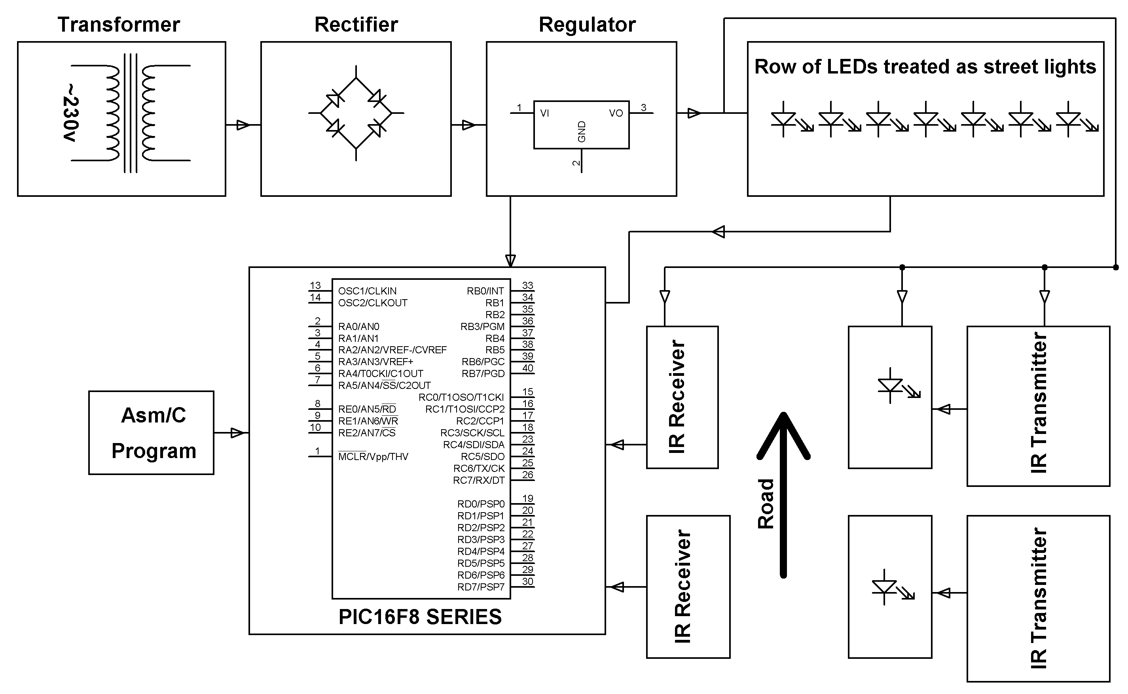

**HARDWARE REQUIRMENT**

**PIC16F8 series microcontroller, Transformer, Diodes, Resistors, Capacitors, Voltage Regulator, LEDs, IR LEDs, Photodiodes, Transistors.**

**SOFTWARE REQUIREMENTS:**

**MPLAB & CCS C compiler**

**Language: Embedded C or Assembly**